Rigging Robot Character - MMED 1025

Part 1: Setting up Helpers

Set up the rig by aligning and adjusting the size (not using Scale) of Point Helpers (set to Box) and standard Circle splines around the robot. Follow the reference images below. Remember to use a proper naming convention for your helpers, they will mostly be named after the anatomy they are controlling. Don’t forget to designate which side of the body any mirrored helpers are on.
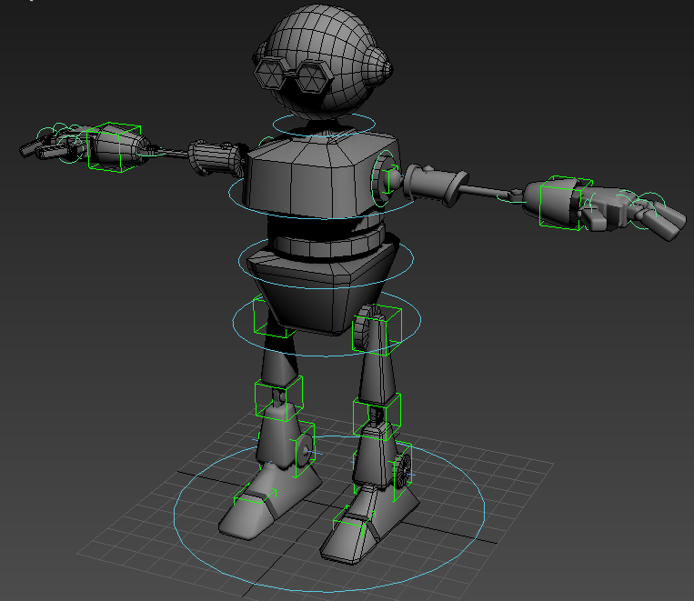

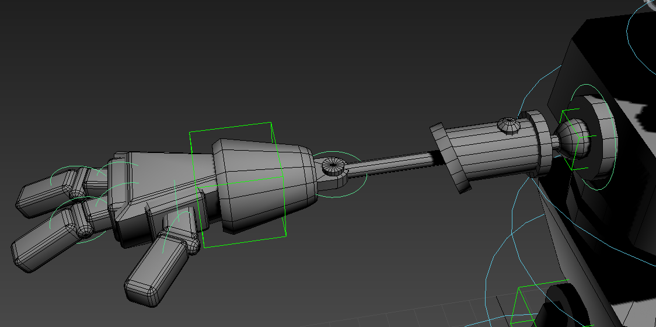
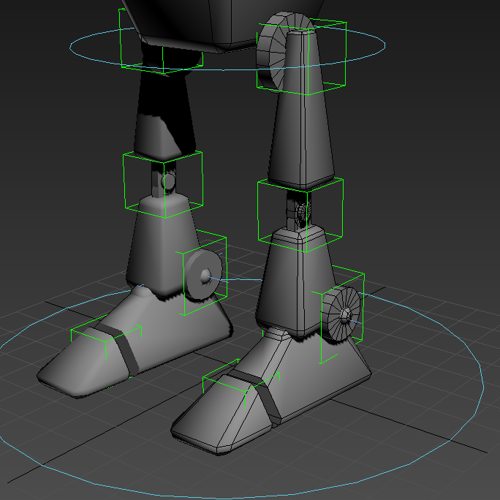
*Note: When aligning the helpers in the legs, remember that the knees are slightly off in the X axis, which will cause the knees to buckle inward or outward. Instead of changing the Pivot Point of the mesh, just align one helper normally (ex: HipHelper), align the next helper (knee) normally, but then re-align Knee helper to HipHelper using only the X Position checkbox. Do the same for the ankle.

Part 2: Selecting and Linking

Let's start with the legs, since they are identical to the Sphere Character.

Ankle Helper to Knee Helper
Knee Helper to Hip Helper
Thigh Mesh to Hip Helper
Calf Mesh to Knee Helper

Toe Mesh to Toe Helper

Create the IK Chain: select the Ankle Helper and go to the main toolbar, Animation--IK Solvers--IK Limb Solver. Once selected, click the HipHelper. If you cannot select it or the IK appears in the Knee, then your linkage is broken somewhere and you will have to re-link some objects.

Move the IK upward to see if it functions properly and the knee does not bend in or out. The IK Chain cross can be scaled upward so it can be seen on the outside of the foot.

Now select and link the Foot Mesh and the Toe Helper to the IK Chain. When you lift your IK chain straight upward, it should look like this:
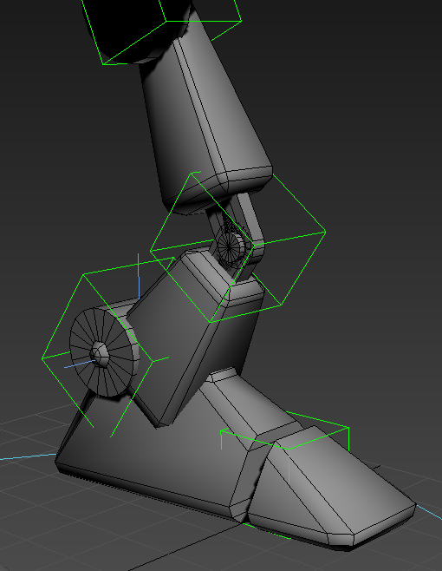
We will do the body helpers last, so let's move onto the arms. Remember to test as you go, not until the whole arm is done. Watch for mesh stretching, likely caused by a helper having a different Scale value, or another object is also linked to it.

In total we have: (per arm)
2 per finger, Root (connected to hand) and End (connected to knuckle)
Wrist
Elbow
X-rotation helper (PointBox around shoulder ball socket)
Z-rotation helper (Circle around shoulder cylinder)

Start from the fingers and link in toward the body.

Finger End Mesh to Finger End Helper
Root mesh to Root Helper
End Helper to Root Helper
Same for other fingers.

3x Finger Root Helper to Wrist Helper
Hand Mesh to Wrist Helper

Wrist Helper to Elbow Helper
Forearm Mesh to Elbow Helper

Bicep arm Mesh to X-Rotation Helper
Elbow Helper to X-Rotation Helper

X-Rot Helper to Z-Rot Helper
Cylinder Mesh to Z-Rot Helper

Body Helpers:
All body helpers are Circle splines, and I designate them with a “Handle” or “Controller/CTRL” suffix.
Neck
Chest
Waist/Spine
Hip
Master Position Control.

Link the following to the HipHandle: Both Hip Helpers from the legs, the Hip/Pelvis Mesh, and the Waist/Spine Handle.
Abs Mesh and Chest Handle link to Waist/Spine Handle

Chest Mesh, Neck Handle, and both Arm Z-Rotation helpers link to Chest Handle.

Head mesh to Neck Handle.

Finally, link the Hip Handle and both IK Chains to the Master Position Control.

Move the Master Position Control to see if the entire robot and rig comes with it. If not, you have some more linking to do.
